**CIS-350  
Infrastructure Technologies**

**Lab 2 Report**

**Student Name**: **Jimi Porter**

**You must use this template to hand in Lab 2 Report.**

1. Insert *Lab2_Tree* file from p. 8 of the Lab 2 instructions into the space provided or use the *Alt-PrtScr* keys to capture the screen output (window) from command *TYPE Lab2_Tree* on p. 8 and paste that window here.

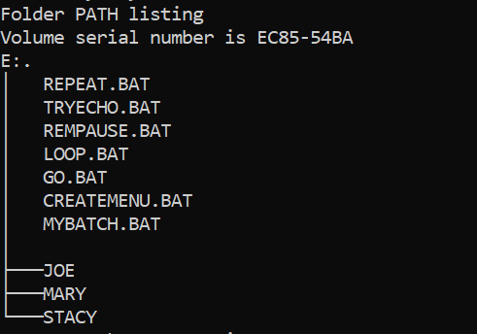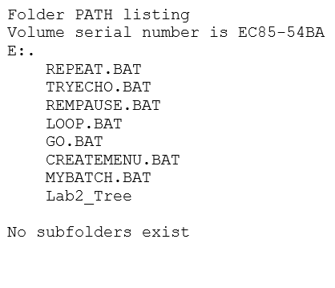

1. Assume that the system prompt displays "C:\>", i.e., your current directory and current drive are the root directory and C drive, respectively. Write a batch file below that will include commands to:
2. prevent all commands from displaying on the screen. Also, disable command ECHO OFF from displaying.
3. display the following message "My first script file"
4. display the directory hierarchy/structure of the C disk (Do not use DIR)
5. display the directory hierarchy/structure of the C disk with all files (Do not use DIR)
6. create subdirectory named *LETTERS* in the root directory
7. erase subdirectory *BOOKS* from the root directory (assume that *BOOKS* does not have any files in it)
8. copy file *loop.bat* to directory *LETTERS*
9. pause the screen
10. use the piping operation to display the sorted directory and display it one screen at a time (prevent the screen from scrolling off). Need to use two pipes.
11. sort data in the descending order coming from file *Names1* and route the output to file *Names1_Sorted*

The batch file, commands (a) through (j):

**Answer:**

1. **Batch File = @ECHO OFF**
2. **Batch File = ECHO My first script file**
3. **Batch File = TREE C:**
4. **Batch File = TREE C: /E**
5. **Batch File = CD LETTERS**
6. **Batch File = ERASE BOOKS**
7. **Batch File = COPY E:\Lab2\LOOP.BAT C:\LETTERS**
8. **Batch File = PAUSE**
9. **Batch File = DIR | SORT | MORE**
10. **Batch File = SORT /R < Names1 > Names1_Sorted**
11. Describe step by step what a file named MYSCRIPT does.

@ECHO OFF

REM STARTING SCRIPT FILE

TREE /F

PAUSE

DIR

PAUSE

MD HANK TOM LISA

TREE /F

PAUSE

COPY *.BAT D:\LAB2\LISA

TREE /F

TREE

PAUSE

CD LISA

ERASE *.BAT

PAUSE

CD ..

TREE /F

PAUSE

RD HANK TOM LISA

TREE /F

PAUSE

REM CLOSING SCRIPT FILE

Assumptions: The prompt D:\LAB2> is displayed. D is the current drive and LAB2 is the current directory just below "\" (the root directory).

|  |  |
| --- | --- |
| **Command** | **Description (Fill in)** |
| **@ECHO OFF** | This command turns off the capability of the echoing and stops ECHO from appearing on the screen. |
| **REM STARTING SCRIPT FILE** | This command displays STARTING SCRIPT FILE to the console. |
| **TREE /F** | This commands illustrates the file design for the lab directory and manages to show subdirectories and files within those directories. |
| **PAUSE** | This command pauses the command currently executing until a user presses a certain key. |
| **DIR** | This command shows the directory contents of the lab. |
| **PAUSE** | This command pauses the command currently executing utnil the user presses a certain key. |
| **MD HANK TOM LISA** | This command creates 3 directories subsequently called HANK, TOM, and LISA. |
| **TREE /F** | This command illustrates the file design of the lab directory by displaying subdirectories and files that lie within. |
| **PAUSE** | This command pauses the command currently executing until the user presses a key. |
| **COPY *.BAT D:\LAB2\LISA** | This command copies every file from the lab directory ending in the .BAT file extension and copies it to the LISA subdirectory. |
| **TREE /F** | This command illustrates the file design for the lab directory and displays subdirectories and files. |
| **TREE** | This command illustrates the file design for the lab directory and displays subdirectories. |
| **PAUSE** | This command pauses a command currently executing until a user presses a certain key. |
| **CD LISA** | This command changes the directory from the lab to LISA. |
| **ERASE *.BAT** | This command erases all files ending in the .BAT file extension. |
| **PAUSE** | This command pauses a command currently executing until a user presses a certain key. |
| **CD ..** | This command changes the directory currently being used to the root directory. |
| **TREE /F** | This command illustrates the file design from the lab directory and displays subdirectories and files within. |
| **PAUSE** | This command pauses the command currently executing until a user presses a certain key. |
| **RD HANK TOM LISA** | This command deletes the directories named, HANK, TOM, and LISA. |
| **TREE /F** | This command illustrates the file design and displays the subdirectories and files within. |
| **PAUSE** | This command pauses the command currently executing until the user presses a certain key. |
| **REM CLOSING SCRIPT FILE** | This command shows the message CLOSING SCRIPT FILE to console. |

1. Optional. Briefly describe any issues with the lab. Point me to the specific pages and suggest changes. Thanks.

**The only issue I had or at least I believe I had was with the first batch file the REPEAT.BAT, it felt like after doing the TYPE command for it, it didn’t produce any results at least from where I could see. I tried it again the next day and it still didn’t show me any of what was listed in the instructions but the other batch files worked fine so its very possible I made a human error twice or was looking in the wrong place for results.**